Portable Trading Network System



**Prepared by:**

**Tafadzwa D. Moyo**

**MYXTAF004**

Department of Electrical Engineering

University of Cape Town

**Prepared for:**

**Dr Simon Winberg**

Department of Electrical Engineering

University of Cape Town

**January 2018**

Submitted to the Department of Electrical Engineering at the University of Cape Town in partial fulfilment of the academic requirements for a Bachelor of Science degree in Electrical and Computer Engineering

**Key Words:** INSERT 4-6 KEYWORDS WHICH DESCRIBE YOUR PROJECT

Declaration

1. **I know that plagiarism is wrong. Plagiarism is to use another's work and pretend that it is one's own.**
2. **I have used the IEEE convention for citation and referencing. Each contribution to, and quotation in, this final year project report from the work(s) of other people, has been attributed and has been cited and referenced.**
3. **This final year project report is my own work.**
4. **I have not allowed, and will not allow, anyone to copy my work with the intention of passing it off as their own work or part thereof**

|  |  |  |  |
| --- | --- | --- | --- |
| **Name:** | **Tafadzwa D. Moyo** |  | |
| **Signature:** |  | **Date:** | 21 March 2018 |

# Terms of Reference

The terms of reference page is an agreement between yourself and your supervisor outlining what is expected of you in your final year project. Please make sure that this is discussed and written at the beginning of your thesis project.

Acknowledgements

Make relevant acknowledgements to people who have helped you complete or conduct this work, including sponsors or research funders.

Abstract

This is a summary of your project. It should not be more than a page in length giving a brief background to the study, the main methodology, results and conclusions drawn.

Table of Contents

Portable Trading Network System 1

Prepared by: 1

Department of Electrical Engineering 1

Prepared for: 1

Department of Electrical Engineering 1

Key Words: INSERT 4-6 KEYWORDS WHICH DESCRIBE YOUR PROJECT 1

Declaration i

Terms of Reference ii

Acknowledgements iii

Abstract iv

Table of Contents v

1. Introduction 1

1.1 Background to the study 1

1.2 Objectives of this study 1

1.2.1 Problems to be investigated 1

1.2.2 Purpose of the study 1

1.3 Scope and Limitations 1

1.4 Plan of development 2

2. Literature Review 3

2.1 Point of Sale Systems 3

2.2 Cloud Services Platforms 4

2.2.1 Amazon Web Services 4

2.2.2 Microsoft Azure 4

2.2.3 Google Cloud Platform 4

2.2.4 Firebase 4

2.3 Smartphone Operating Systems 5

2.3.1 Android 5

2.3.2 iOS 5

2.4 Prototyping Solutions 6

2.4.1 Adobe XD 6

2.5 Android Studio 6

2.6 Development solutions 6

2.6.1 QR Codes 6

2.6.2 Mobile Vision Barcode API 7

3. Methodology 9

3.1 Phase 1: Research and Review of Literature 9

3.2 Phase 2: Prototype Design 9

3.3 Phase 3: Final Design 9

3.4 Phase 4: Development 9

3.5 Phase 5: User Review 9

3.6 Phase 6: Conclusions and Recommendations 9

4. Results 10

5. Discussion 11

6. Conclusions 12

7. Recommendations 13

8. List of References 14

9. Appendices 15

10. EBE Faculty: Assessment of Ethics in Research Projects 16

Simply right click on the table of contents when you have completed your document and update the field. Please check to see that it is correct before printing and delete any unnecessary details. You may also do it manually if you want just please check that it is correct.

Try and avoid using more than three heading levels in your chapters.

# Introduction

## Background to the study

A very brief background to your area of research. Start off with a general introduction to the area and then narrow it down to your focus area. Used to set the scene.

## Objectives of this study

The objective of this study is to create a cloud based system that an Android app client interface and server that can be hosted on a regular cloud infrastructure service such as Google Cloud. The system is designed to assist with the running and coordination of one or more trading sites that are situated in outdoor markets, street markets, tradeshows and other trade contexts.

The system must meet the following requirements:

* Support for multiple users and access levels (e.g. manager, cashier, shop assistant)
* Chat / Instance Messaging (IM) between Android client apps
* Server / master client – where the backend runs. Stores the database to keep track of stock etc. Logs chat IM.
* Stock logging. Add stock / sell stock / discard stock (i.e. mark stock items as spoilt). Updates server.
* POS functionality – handle selling, generate receipts (hint, see receipt cloud project the student of which you might collaborate with). Handle returns/refunds/exchanges.
* Handle discounts, gift cards or store credit (e.g. on a return the user might be given credit instead of cash).
* Mechanism to adjust prices, etc. (might not be accessible through POS).
* Balance enquiry. Able to email the user an account balance (e.g. if they received a credit refund for a return).
* Added ‘Intelligence’ – e.g. alters users and manager to high volume / low volume trading, for instance if one stall is very busy and another is not busy then the service sends a message to the non-busy stall to suggest sending an assistant to help.

### Problems to be investigated

The problems to be investigated in this study how a cloud based system that has an Android app interface can assist outdoor markets, street markets, tradeshows and other trade contexts in the running and coordination of one or more trading sites.

### Purpose of the study

Give the significance of investigating these problems. It must be obvious why you are doing this study and why it is relevant.

## Scope and Limitations

Scope indicates to the reader what has and has not been included in the study. Limitations tell the reader what factors influenced the study such as sample size, time etc. It is not a section for excuses as to why your project may or may not have worked.

## Plan of development

Here you tell the reader how your final year project report has been organised and what is included in each chapter.

**I recommend that you write this section last. You can then tailor it to your report.**

# Literature Review

## Point of Sale Systems

A point of sale system is a system that registers sales and payments at the point of sale. A point of sale(POS) is the place where sales occur. The main purpose of a POS system is keep an audit trail. The audit trail has evidence for each financial transaction that happens within the system. [1] POS systems designs are different but there are two properties than are important:

1. The POS system has an audit trail. [1]
2. Many devices are attached to the POS system, devices such as keyboards, bar code scanners, payment terminals (for credit/debit cards), display for customers and the operator, and receipt printers. [1]

POS Systems offer two main operations:

1. Recording sale and payment in an audit trail. [1]
2. Producing evidence of sales and payments from the audit trail. [1]

Figure 1 shows a model of a POS System.

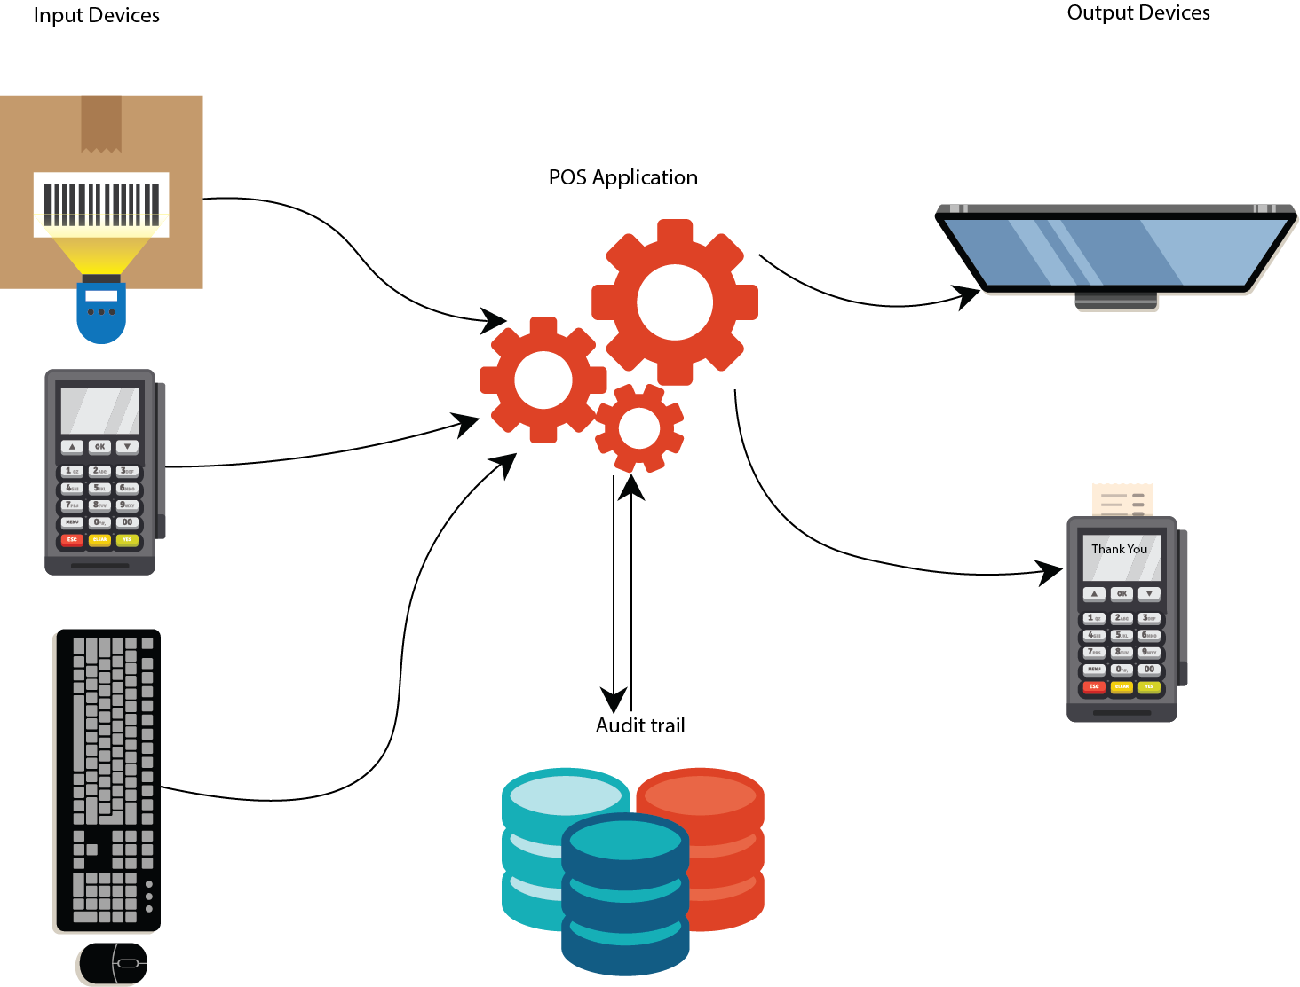

Figure 1: POS system model with input and output data flows

The input/output data flows and the audit trail must have integrity and appropriate confidentiality. [1] The appropriate degree of confidentiality depends on the user’s role.

Possible roles include:

1. Customer

A user who wants to buy a product of service. [1]

1. Operator

A user who is responsible for recording sold goods or services and received payments, and giving the customer evidence of the purchase. [1]

1. Financial Manager

A user who can retrieve financial information from the audit trail. [1]

1. Administrator

A user who can install, configure and maintain system functions. [1]

## Unified Modeling Language(UML)

Unified Modeling Language(UML) is a visual language that is used to design systems. It is not a programming language but rather it is a set of tools used to design software system, the code would be made based on the design. [2] Elements are used and associated in different ways to represent static or structural parts of the system and dynamic parts of the systems. [2]

### Structural UML diagrams

These diagrams represent that structural aspects of system. There are different types of structural diagrams but the most used is the class diagram. [2]Class diagrams are made of classes grouped to represent a system. They show the classes within a system, their attributes and operations and relationships between them. [2] A class the blueprint is an object. [2] An object represents a basic entity or building block within a system[2] An example of a class diagram is shown in figure

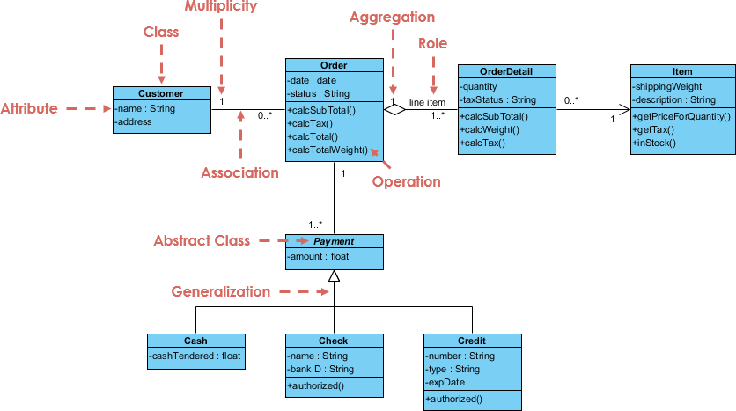

Figure 2: Example of class diagram[3]

### Behavioural UML diagrams

These diagrams represent that dynamic aspects of system. There are different types of behavioural diagrams. [2] Three types are listed below:

1. Activity Diagrams

It the activity of any part or component of system. [2] An example of an activity diagram is shown in figure:

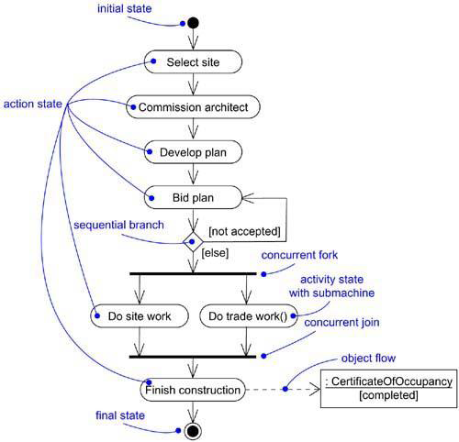

Figure 3: Example of activity diagram[4]

1. Sequence Diagram

It shows the interactions between objects and when they occur. They show interactions for a scenario, so each scenario has its own sequence diagram. [2] An example of a sequence diagram is shown in figure:

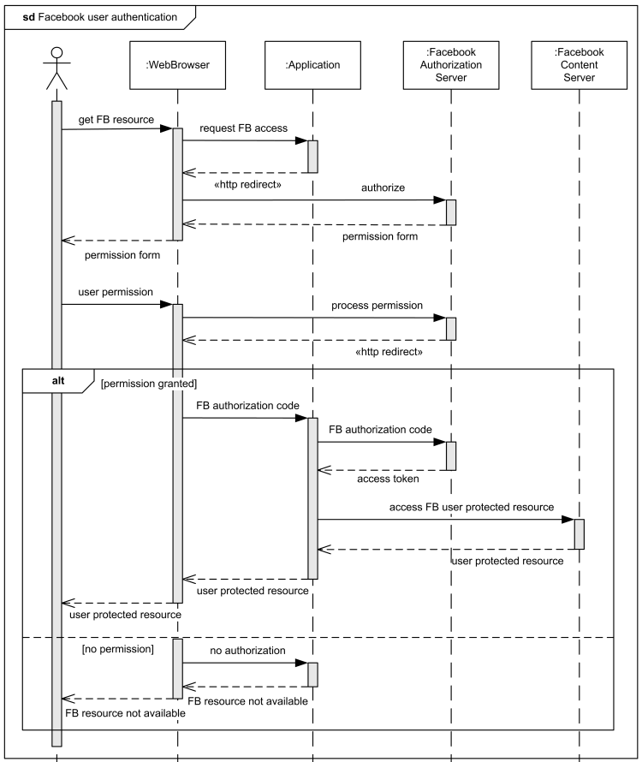

Figure 4: Example of sequence diagram[5]

1. Use Case Diagram

It shows specific function of the system, how it relates with other functions and its internal/external controllers(actors). [2] An example of a use case diagram is shown in figure:

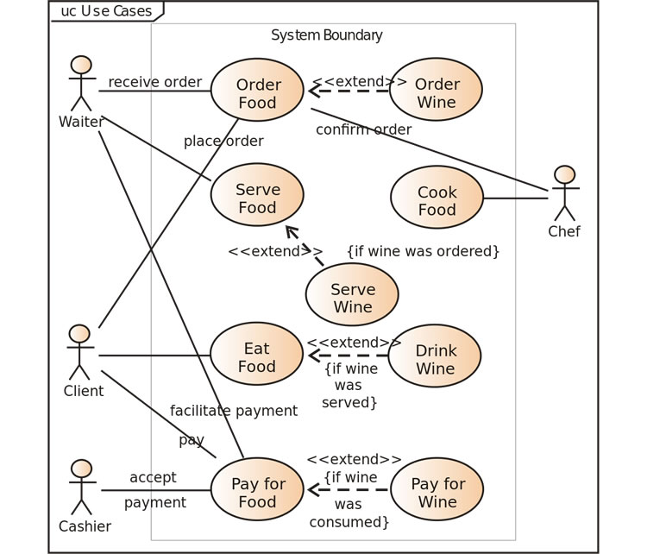

Figure 5: Example of use case diagram[6]

## Cloud Services Platforms

Cloud computing is the delivery of processing power, database storage, applications and other IT resources via the Internet. It allows for a broad set of application services to be accessed via the internet. A cloud services platform owns and maintains the hardware required for those application services. Cloud computing can avoid the large hardware investment and management costs that owning their own servers would cost them.[7]

### Amazon Web Services

Amazon Web Services(AWS) is a cloud services platform offered by Amazon. [7] AWS offers many cloud services including Amazon Elastic Compute Cloud (Amazon EC2). Amazon EC2 is designed to make web-scale computing easier developers. [7]

### Microsoft Azure

Azure is a cloud services platform offered by Microsoft. The Azure platform has many cloud services. It also has integrated tools, DevOps, and a marketplace which aid developers. [8]

### Google Cloud Platform

Google Cloud Platform is a cloud services platform offered by Google. Google Cloud Platform has many cloud services. [9]

### Firebase

Firebase is a cloud services platform offered by Google. Firebase make it easier for developers to develop mobile applications. It runs on the Google Cloud Platform. It has services include realtime databases, realtime crash reporting, Cloud Firestore – it allows for application data to be stored and synced, user authentication and Test Lab for Android-it allows you to test android application on devices hosted by Google. [10] It cloud services support Android, iOS and web applications. [11]

## JavaScript

JavaScript ("JS" for short) is a dynamic programming language that allows an HTML document to become interactive. It was invented by Brendan Eich, co-founder of the Mozilla project, the Mozilla Foundation, and the Mozilla Corporation. [12]

### Promises

A promise is a proxy for a value that may not be known when the promise is created. It for handlers to be associated with an asynchronous action's eventual success value or failure reason. This allows asynchronous functions to return values like synchronous functions: instead of return an actual value the asynchronous function returns the promise to eventually supply the actual value. [13]

According to [13] promises have the following states:

1. pending: initial state, neither fulfilled nor rejected.
2. fulfilled: meaning that the operation completed successfully.
3. rejected: meaning that the operation failed.

### Async Functions

An async function is a function that always returns a promise. If the function has return <non-promise> in it, then JavaScript automatically wraps it into a resolved promise with that value.[14]. Async function can use an *await* expression within its body. [15] The *await* expression pauses the execution of the async function in a nonblocking manor and waits until the promise settles.[15] [16] If the promise fulfills, you get the value back. If the promise rejects, the rejected value is thrown.[15]

### Web Workers

Workers (or web workers) are JavaScript scripts that scripts that run in the background independent of any user interface scripts. They can run for long without being interrupted by scripts that respond to clicks or other user interactions. This allows for tasks to run in the background without being interrupted to keep the web page responsive. [17] Workers have high start-up performance and per instance memory costs so using them in large numbers in not ideal. [17]

## HTML

HTML stands for Hyper Text Markup Language and it describes the structure of Web pages using markup.[18] Markup is a set of tags assigned to elements to indicate how they should be displayed.[19] HTML elements are the building blocks of HTML pages[18] HTML5 was the latest version of HTML at the time when this report was written.[20]

### HTML DOM

The HTML DOM is a standard object model and programming interface for HTML. It can also be defined as a standard for how to get, change, add, or delete HTML elements[21]

According to [21] HTML DOM specifies:

1. HTML elements as objects
2. properties of all HTML elements
3. methods to access all HTML elements
4. events for all HTML elements

## Cascading Style Sheets

Cascading Style Sheets (CSS) describe how HTML elements are to be laid out on a screen, paper or any other media. CSS can control multiple web pages at the same time. [22] CSS can either be embedded in an HTML file or be stored in a separate file of type CSS.[23]

## Node.js

According to the Node.js Foundation, “Node.js® is a JavaScript runtime built on Chrome's V8 JavaScript engine. Node.js uses an event-driven, non-blocking I/O model that makes it lightweight and efficient. Node.js' package ecosystem, npm, is the largest ecosystem of open source libraries in the world.”[24]

Node.js is a free, open source JavaScript server framework. [25] Node.js is used for developing server-side and networking applications. It is run within the Node.js runtime environment on OS X, Microsoft Windows, and Linux. [26]

## NPM

NPM is a package manager for Node.js packages. A package in Node.js contains all the files needed for a module. Modules are JavaScript libraries that can be include in projects. The packages are hosted on [www.npmjs.com](http://www.npmjs.com). They are free to download and use. The NPM program is installed on a computer when Node.js is installed.[27]

## Bootstrap

Bootstrap is a HTML, CSS, and JS web front-end component library. It is used to build responsive, mobile-first projects on the web applications.[28]

## AngularJS

AngularJS is a JavaScript Framework. It adds additional attributes to HTML DOM and makes it more responsive to user actions. It is used in Single Page Application (SPA) projects. [29]

## Syntactically Awesome Stylesheet

Syntactically Awesome Stylesheet (SASS) is a CSS pre-processor.[30] A pre-processor is a program that takes one type of data and converts it to another type of data.[31] SASS helps to reduce repetition with CSS and saves time. It is more stable and powerful CSS extension language that describes the style of document structurally. [30]

## Smartphone Operating Systems

### Android

Android is an operating system that is based on Linux. It operates on mobile phones and other devices like TVs, car and watches. [32] According to Statista Android held 87.7% of the global market in the second quarter of 2017. [33] Figure 1 shows two android devices.

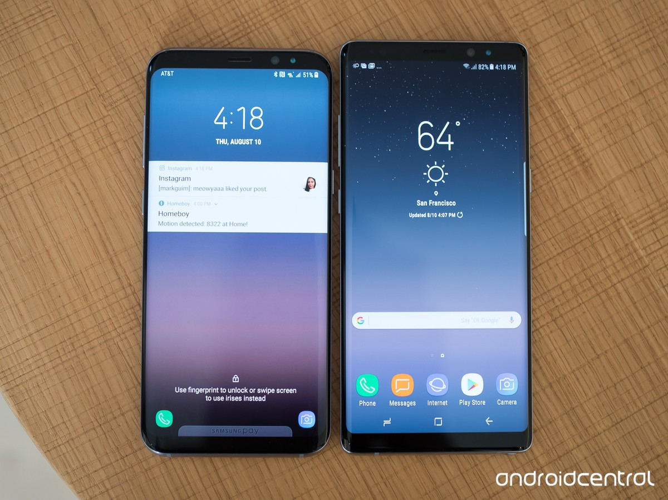

Figure 6: Samsung S8+ to the left and Samsung Note 8 to the right[34]

### iOS

iOS is an operating system offered by Apple. It operates on iPhones and iPads.[35] According to Statista iOS held 12.1% of the global market in the second quarter of 2017. [33] Figure 2 shows two devices that run the iOS operating system

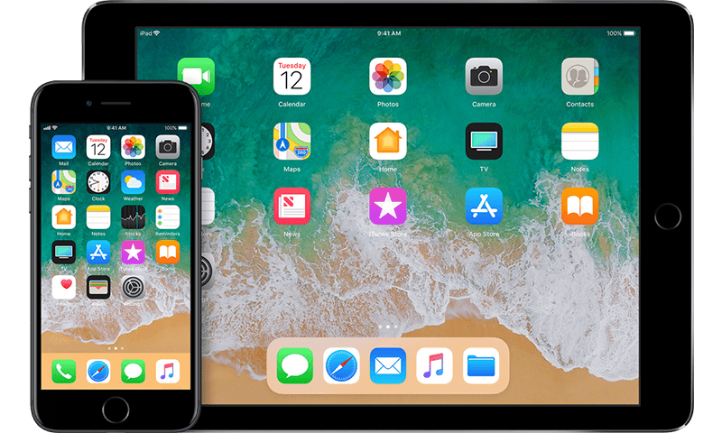

Figure 7: iPhone on the left and iPad on the right[35]

## Progressive Web Apps

Progressive Web Apps are web applications that can access native services like location and camera. [36] Progressive Web Apps are engaging, reliable and fast. [37] They are engaging because they are can be installed without an app store and they can have an icon on the home screen. [37] They are reliable and fast because they service workers allow them to load instantly no matter what the network state is. [37]

### Application Shell

The application shell (or app shell) is the minimal HTML, CSS and JavaScript that is needed to power the user interface. When the app shell is cached is allow for users to have an instant, reliably good performances when they revisit the web app. This happens because it will not be reloaded every time the user re visits the web app. Only the necessary content is needed from the network.[38] Figure shows the difference between an application shell and necessary content.

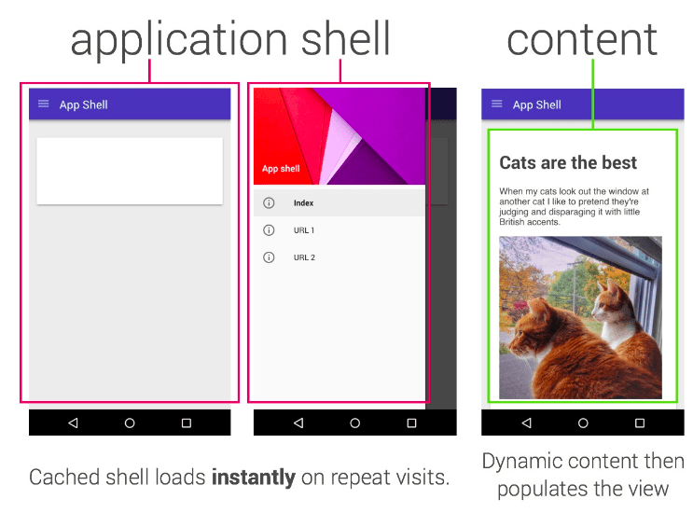

Figure 8: Difference between an application shell and content, image source([38])

### Service Worker

A service worker is a web worker. Its features include push notifications, background sync and managing a cache of response. [39]

Service workers allow a developer to control the cache and how to respond to resource requests. [37] Key resources can be pre-cached so they only need to be downloaded once. The resources will be fetched from the cache whenever the app is run. [37] [40]Service workers are written in JavaScript. [37]

## Prototyping Solutions

### Adobe XD

## Development solutions

### QR Codes

A QR code, which stands for “Quick Response” code, is a 2D matrix that was designed to store data. It was labelled “Quick Response” code because it was designed to be decoded quickly. QR Code is a 2-D barcode.[41]

The QR Code system has two parts which are the QR Code encoder and the QR Code decoder. The QR Code encoder takes data and generates a QR Code symbol. The QR Code decoder decodes data from a QR Code symbol. [41]. Figure 3 shows a visual representation of how the QR Code system works.

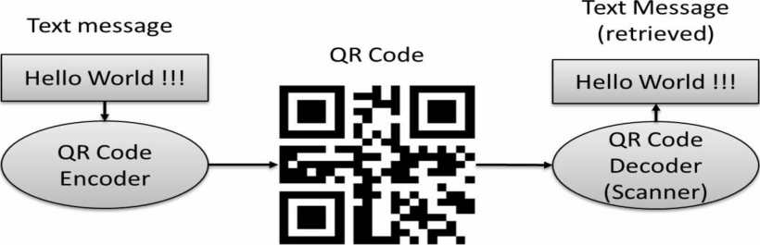

Figure 9: Working (overview) of QR code[41]

QR code has the following features:

1. **High Capacity of Encoding Data**

1D or linear barcodes are the black-and-white-striped codes that can be found on most consumer products[42] and they are able to store a maximum of 20 digits.[43] QR Codes can stored several hundred times more data that 1D or linear barcodes. [43]

1. **Small Printout Size**

A QR code is able to store the same amount of data as a 1D barcode in a using approximately on tenth of the space. [43]

1. **Dirt and Damage Resistant**

With QR Code data can be recovered if the symbol if dirty or damaged. [43]

1. **Readable in any direction**

QR Code is capable of high speed reading in any direction.[43]

### Mobile Vision Barcode API

The Mobile Vision API is a framework for detecting objects within images and videos which was developed by Google Developers. [44] Within the Mobile Vision API there is the Barcode API which can detect barcodes in real time. It supports many types of barcodes including QR Code. [45]

The Barcode API parse QR Code for the following formats[45]:

* URL[45]
* Contact information (VCARD, etc.)[45]
* Calendar event[45]
* Email[45]
* Phone[45]
* SMS[45]
* ISBN[45]
* WiFi[45]
* Geo-location (latitude and longitude) [45]
* AAMVA driver license/ID[45]

# Methodology

## Phase 1: Research and Review of Literature

## Phase 2: Prototype Design

## Phase 3: Final Design

## Phase 4: Development

## Phase 5: User Review

## Phase 6: Conclusions and Recommendations

# Prototype Design

### UML of Prototype Design

# Results of Prototype Design

# UML of Final Design

# Results of Final Design

Present your results in a suitable format using tables and graphs where necessary. Remember to refer to them in text and caption them properly.

# Discussion

Discuss the relevance of your results and how they fit into the theoretical work you described in your literature review.

# Conclusions

Draw suitable and intelligent conclusions from your results and subsequent discussion.

# Recommendations

Make sensible recommendations for further work.

# List of References

[1] A. Pedersen, N. Partner, A. Hedegaard, and R. Sharp, “Designing a secure point-of-sale system,” *Fourth IEEE Int. Work. Inf. Assur.*, 2006.

[2] Lucid Software Inc, “What is Unified Modeling Language.” [Online]. Available: https://www.lucidchart.com/pages/what-is-UML-unified-modeling-language. [Accessed: 05-Mar-2018].

[3] Visual Paradigm, “UML Class Diagram Tutorial.” [Online]. Available: https://www.visual-paradigm.com/guide/uml-unified-modeling-language/uml-class-diagram-tutorial/. [Accessed: 05-Mar-2018].

[4] P. Thomas, “Activity Diagrams.” [Online]. Available: https://praveenthomasln.wordpress.com/tag/activity-diagrams-in-uml/. [Accessed: 05-Mar-2018].

[5] uml-diagrams.org, “Facebook Web User Authentication.” [Online]. Available: https://www.uml-diagrams.org/facebook-authentication-uml-sequence-diagram-example.html. [Accessed: 05-Mar-2018].

[6] J. Erickson, “Smart UX: Use Cases,” *UsabilityGeek*. [Online]. Available: https://usabilitygeek.com/smart-ux-use-cases/. [Accessed: 05-Mar-2018].

[7] S. Mathew, “Overview of Amazon Web Services,” 2017.

[8] Microsoft, “What is Azure?” [Online]. Available: https://azure.microsoft.com/en-us/overview/what-is-azure/. [Accessed: 03-Jan-2018].

[9] Google, “Overview.” [Online]. Available: https://cloud.google.com/docs/overview/. [Accessed: 03-Jan-2018].

[10] Google Developers, “Firebase.” [Online]. Available: https://firebase.google.com/. [Accessed: 03-Jan-2018].

[11] Google Developers, “Products.” [Online]. Available: https://firebase.google.com/products/. [Accessed: 03-Jan-2018].

[12] Mozilla, “JavaScript basics.” [Online]. Available: https://developer.mozilla.org/en-US/docs/Learn/Getting_started_with_the_web/JavaScript_basics. [Accessed: 19-Mar-2018].

[13] Mozilla, “Promise.”

[14] I. Kantor, “Async/await,” *Javascript.io*. [Online]. Available: https://javascript.info/async-await. [Accessed: 19-Mar-2018].

[15] J. Archibald, “Async functions - making promises friendly,” *Google Developers*. [Online]. Available: https://developers.google.com/web/fundamentals/primers/async-functions. [Accessed: 19-Mar-2018].

[16] Mozilla, “async function.” [Online]. Available: https://developer.mozilla.org/en-US/docs/Web/JavaScript/Reference/Statements/async_function. [Accessed: 19-Mar-2018].

[17] WHATWG, “Web workers,” *HTML Living Standard*, 2018. [Online]. Available: https://html.spec.whatwg.org/multipage/workers.html. [Accessed: 19-Mar-2018].

[18] W3Schools, “HTML Introduction.” [Online]. Available: https://www.w3schools.com/html/html_intro.asp. [Accessed: 21-Mar-2018].

[19] Google, “Markup.” [Online]. Available: https://www.google.co.za/search?q=markup&oq=markup&aqs=chrome..69i57j69i61j0l4.1511j0j7&sourceid=chrome&ie=UTF-8. [Accessed: 21-Mar-2018].

[20] Mozilla, “HTML5,” *MDN Web Docs*. [Online]. Available: https://developer.mozilla.org/en-US/docs/Web/Guide/HTML/HTML5. [Accessed: 21-Mar-2018].

[21] W3Schools, “JavaScript HTML DOM.” [Online]. Available: https://www.w3schools.com/js/js_htmldom.asp.

[22] W3Schools, “CSS Introduction.” [Online]. Available: https://www.w3schools.com/css/css_intro.asp. [Accessed: 21-Mar-2018].

[23] W3Schools, “CSS How To...” [Online]. Available: https://www.w3schools.com/css/css_howto.asp. [Accessed: 21-Mar-2018].

[24] Node.js Foundation and Joyent, “Node.JS.” [Online]. Available: https://nodejs.org/en/. [Accessed: 22-Mar-2018].

[25] W3Schools, “Node.js Introduction.” [Online]. Available: https://www.w3schools.com/nodejs/nodejs_intro.asp. [Accessed: 22-Mar-2018].

[26] Tutorials Point, “Node.js - Introduction.” [Online]. Available: https://www.tutorialspoint.com/nodejs/nodejs_introduction.htm. [Accessed: 22-Mar-2018].

[27] W3Schools, “Node.js NPM.” [Online]. Available: https://www.w3schools.com/nodejs/nodejs_npm.asp. [Accessed: 22-Mar-2018].

[28] “Bootstrap: The most popular HTML, CSS, and JS library in the world.” [Online]. Available: https://getbootstrap.com/.

[29] Tutorials Point, “AngularJS Tutorial.” [Online]. Available: https://www.tutorialspoint.com/angularjs/index.htm. [Accessed: 21-Mar-2018].

[30] Tutorials Point, “Sass Tutorial.” [Online]. Available: https://www.tutorialspoint.com/sass/index.htm. [Accessed: 21-Mar-2018].

[31] S. Howe, “Preprocessors.” [Online]. Available: https://learn.shayhowe.com/advanced-html-css/preprocessors/. [Accessed: 21-Mar-2018].

[32] O. C. Novac, M. Novac, and C. Gordan, “Comparative study of Google Android, Apple iOS and Microsoft Windows Phone mobile operating systems,” *2017 14th Int. Conf. Eng. Mod. Electr. Syst.*, 2017.

[33] Statista, “Global mobile OS market share in sales to end users from 1st quarter 2009 to 2nd quarter 2017.” [Online]. Available: https://www.statista.com/statistics/266136/global-market-share-held-by-smartphone-operating-systems/. [Accessed: 03-Jan-2018].

[34] A. MARTONIK, “Samsung Galaxy Note 8: Specs, pricing, best features, and problems,” 2018. [Online]. Available: https://www.androidcentral.com/samsung-galaxy-note-8. [Accessed: 03-Jan-2018].

[35] Apple Inc., “iOS.” [Online]. Available: https://developer.apple.com/ios/. [Accessed: 03-Jan-2018].

[36] C. Hoffman, “What Are Progressive Web Apps?,” *How to Geek*, 2018. [Online]. Available: https://www.howtogeek.com/342121/what-are-progressive-web-apps/. [Accessed: 19-Mar-2018].

[37] Google Developers, “Progressive Web Apps.” [Online]. Available: https://developers.google.com/web/progressive-web-apps/. [Accessed: 19-Mar-2018].

[38] A. Osmani, “The App Shell Model,” *Google Developers*, 2018. [Online]. Available: https://developers.google.com/web/fundamentals/architecture/app-shell. [Accessed: 19-Mar-2018].

[39] M. Gaunt, “What is a service worker,” *Google Developers*. [Online]. Available: https://developers.google.com/web/fundamentals/primers/service-workers/. [Accessed: 19-Mar-2018].

[40] P. LePage, “Your First Progressive Web App,” *Google Developers*. [Online]. Available: https://developers.google.com/web/fundamentals/codelabs/your-first-pwapp/. [Accessed: 19-Mar-2018].

[41] S. Tiwari, “An Introduction to QR Code Technology,” *2016 Int. Conf. Inf. Technol.*, 2016.

[42] F. von Reischach, S. Karpischek, and F. Michahelles, “Evaluation of 1D barcode scanning on mobile phones,” *Internet of Things (IOT)*, 2010.

[43] DENSO WAVE INCORPORATED, “What is a QR Code?” [Online]. Available: http://www.qrcode.com/en/about/. [Accessed: 27-Oct-2017].

[44] Google Developers, “Introduction to Mobile Vision,” 2016. [Online]. Available: https://developers.google.com/vision/introduction. [Accessed: 27-Oct-2017].

[45] Google Developers, “Barcode API Overview,” 2017. [Online]. Available: https://developers.google.com/vision/android/barcodes-overview. [Accessed: 27-Oct-2017].

# Appendices

Add any information here that you would like to have in your project but is not necessary in the main text. Remember to refer to it in the main text. Separate your appendices based on what they are for example. Equation derivations in Appendix A and code in Appendix B etc.

# EBE Faculty: Assessment of Ethics in Research Projects

Any person planning to undertake research in the Faculty of Engineering and the Built Environment at the University of Cape Town is required to complete this form before collecting or analysing data. When completed it should be submitted to the supervisor (where applicable) and from there to the Head of Department. If any of the questions below have been answered YES, and the applicant is NOT a fourth year student, the Head should forward this form for approval by the Faculty EIR committee: submit to Ms Zulpha Geyer ([Zulpha.Geyer@uct.ac.za](mailto:Zulpha.Geyer@uct.ac.za); Chem Eng Building, Ph 021 650 4791).Students must include a copy of the completed form with the final year project when it is submitted for examination.

|  |  |  |  |  |  |
| --- | --- | --- | --- | --- | --- |
| **Name of Principal Researcher/Student:** | |  | | **Department:** | ELECTRICAL ENGINEERING |
| **If a Student:** | YES | **Degree:** |  | **Supervisor:** |  |
| **If a Research Contract indicate source of funding/sponsorship:** | | | |  | |
| **Research Project Title:** | |  | | | |

Overview of ethics issues in your research project:

|  |  |  |
| --- | --- | --- |
| **Question 1: Is there a possibility that your research could cause harm to a third party (i.e. a person not involved in your project)?** | YES | NO |
| **Question 2: Is your research making use of human subjects as sources of data?**  If your answer is YES, please complete Addendum 2. | YES | NO |
| **Question 3: Does your research involve the participation of or provision of services to communities?**  If your answer is YES, please complete Addendum 3. | YES | NO |
| **Question 4: If your research is sponsored, is there any potential for conflicts of interest?**  If your answer is YES, please complete Addendum 4. | YES | NO |

If you have answered YES to any of the above questions, please append a copy of your research proposal, as well as any interview schedules or questionnaires (Addendum 1) and please complete further addenda as appropriate.

I hereby undertake to carry out my research in such a way that

* there is no apparent legal objection to the nature or the method of research; and
* the research will not compromise staff or students or the other responsibilities of the University;
* the stated objective will be achieved, and the findings will have a high degree of validity;
* limitations and alternative interpretations will be considered;
* the findings could be subject to peer review and publicly available; and
* I will comply with the conventions of copyright and avoid any practice that would constitute plagiarism.

Signed by:

|  |  |  |
| --- | --- | --- |
|  | **Full name and signature** | **Date** |
| **Principal Researcher/Student:** | **\*\*\*Replace with Your Name\*\*\*** | 21 March 2018 |

This application is approved by:

|  |  |  |
| --- | --- | --- |
| **Supervisor (if applicable):** | **\*\*\*Replace with Supervisor's Name\*\*\*** | 21 March 2018 |
| **HOD (or delegated nominee):**  Final authority for all assessments with NO to all questions and for all undergraduate research. | **Janine Buxey** | 21 March 2018 |
| **Chair : Faculty EIR Committee**  For applicants other than undergraduate students who have answered YES to any of the above questions. |  |  |

**ADDENDUM 1:**

Please append a copy of the research proposal here, as well as any interview schedules or questionnaires:

**ADDENDUM 2:** To be completed if you answered YES to Question 2:

It is assumed that you have read the UCT Code for Research involving Human Subjects (available at <http://web.uct.ac.za/depts/educate/download/uctcodeforresearchinvolvinghumansubjects.pdf>) in order to be able to answer the questions in this addendum.

|  |  |  |
| --- | --- | --- |
| 2.1 Does the research discriminate against participation by individuals, or differentiate between participants, on the grounds of gender, race or ethnic group, age range, religion, income, handicap, illness or any similar classification? | YES | NO |
| 2.2 Does the research require the participation of socially or physically vulnerable people (children, aged, disabled, etc) or legally restricted groups? | YES | NO |
| 2.3 Will you not be able to secure the informed consent of all participants in the research?  (In the case of children, will you not be able to obtain the consent of their guardians or parents?) | YES | NO |
| 2.4 Will any confidential data be collected or will identifiable records of individuals be kept? | YES | NO |
| 2.5 In reporting on this research is there any possibility that you will not be able to keep the identities of the individuals involved anonymous? | YES | NO |
| 2.6 Are there any foreseeable risks of physical, psychological or social harm to participants that might occur in the course of the research? | YES | NO |
| 2.7 Does the research include making payments or giving gifts to any participants? | YES | NO |

If you have answered YES to any of these questions, please describe below how you plan to address these issues:

**ADDENDUM 3:** To be completed if you answered YES to Question 3:

|  |  |  |
| --- | --- | --- |
| 3.1 Is the community expected to make decisions for, during or based on the research? | YES | NO |
| 3.2 At the end of the research will any economic or social process be terminated or left unsupported, or equipment or facilities used in the research be recovered from the participants or community? | YES | NO |
| 3.3 Will any service be provided at a level below the generally accepted standards? | YES | NO |

If you have answered YES to any of these questions, please describe below how you plan to address these issues:

**ADDENDUM 4:** To be completed if you answered YES to Question 4

|  |  |  |
| --- | --- | --- |
| 4.1 Is there any existing or potential conflict of interest between a research sponsor, academic supervisor, other researchers or participants? | YES | NO |
| 4.2 Will information that reveals the identity of participants be supplied to a research sponsor, other than with the permission of the individuals? | YES | NO |
| 4.3 Does the proposed research potentially conflict with the research of any other individual or group within the University? | YES | NO |

If you have answered YES to any of these questions, please describe below how you plan to address these issues: